**Q1**

1. (aa|ab|ba|bb)*
2. b*(ab*ab*)*ab*
3. a*(ba*ba*)*
4. (a(a|b)*b)|(b(a|b)*a)
5. (b|ab)+b+
6. 1 ((110|111|101)(0|1)(0|1)) | 1(0|1)(0|1)(0|1)(0|1)(0|1)(0|1)+
7. (integer+) (letter+) (((0(4|5|6|7|8|9)) | ((1|2|3(digit) | (4(0|1|2|3|4)))

**Q2**

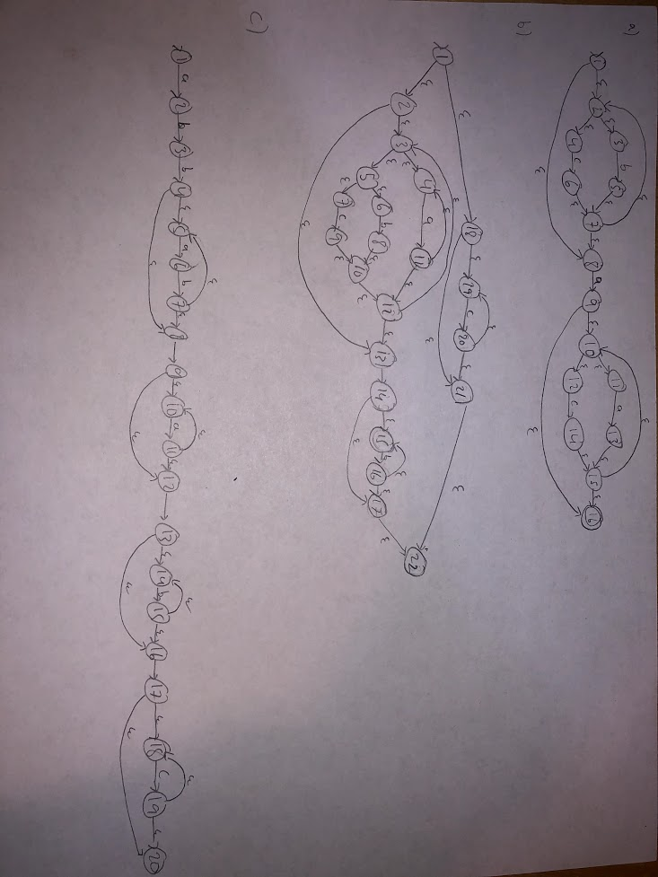

**Q3**